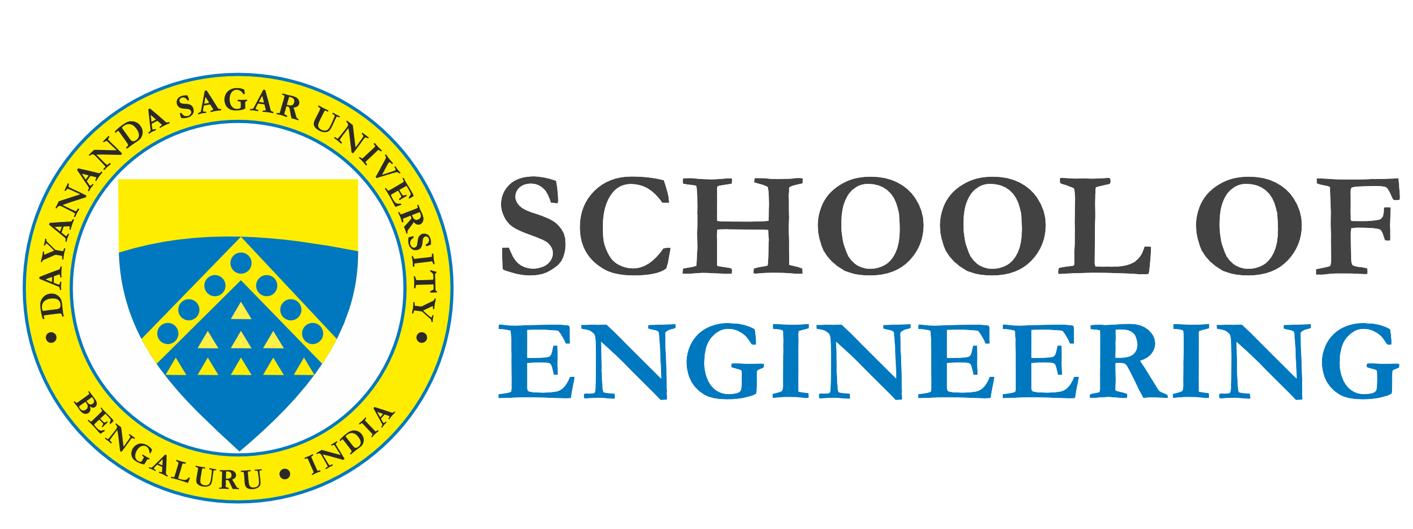DAYANANDA SAGAR UNIVERSITY

**Bachelor of Technology**

in

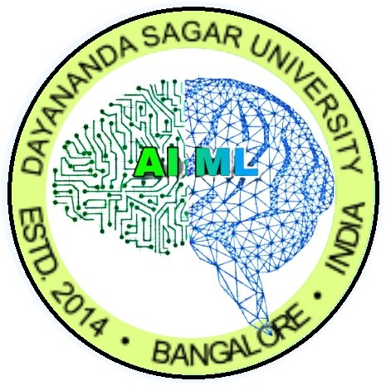Computer Science and Engineering (ARTIFICIAL INTELLIGENCE AND MACHINE LEARNING)

A Project Report On

**NATURAL LANGUAGE MODELS 22AM3610**

CHATBOTS & CONVERSATIONAL AI: COLLEGE ENQUIRY CHAYBOT

*Submitted By*

**Ayush Mishra (ENG22AM0080)**

**Aryan Hayaran (ENG22AM0077)**

*Under the guidance of*

**Prof. Pradeep Kumar K**

Assistant Professor, CSE(AIML), DSU

**2025 - 2026**

Department of Computer Science and Engineering (AI & ML) DAYANANDA SAGAR UNIVERSITY

Bengaluru - 560068

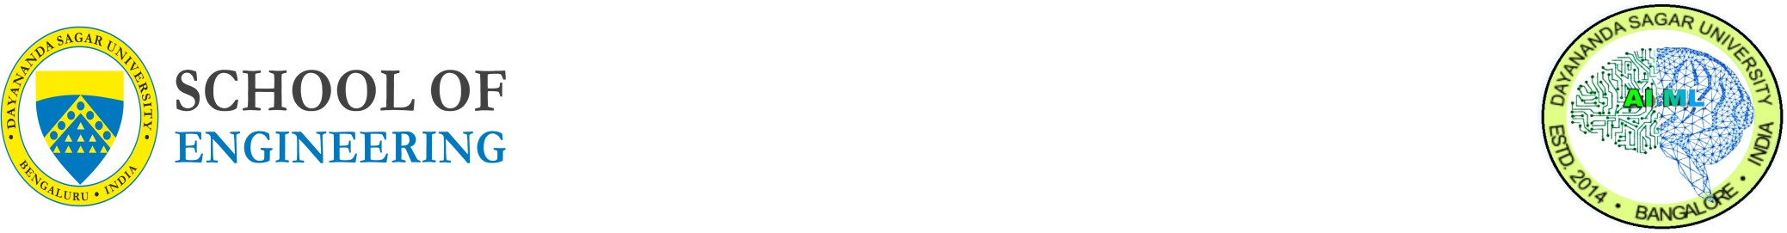

Dayananda Sagar University

Devarakaggalahalli, Harohalli Kanakapura Road, Ramanagara, Karnataka 562112

**Department of Computer Science & Engineering (Artificial Intelligence & Machine Learning)**

**CERTIFICATE**

This is to certify that the project entitled **CHATBOTS & CONVERSATIONAL AI: COLLEGE ENQUIRY CHATBOT** is a bonafide work carried out by **Ayush Mishra (ENG22AM0080)**, **Aryan Hayaran (ENG22AM0077)** in partial fulfillment for the award of degree in Bachelor of Technology in Computer Science and Engineering (Artificial Intelligence and Machine Learning), during the year 2023-2024.

**Prof. Pradeep Kumar** Assistant Professor Dept. of CSE (AIML) School of Engineering

Dayananda Sagar University

Signature .........................

**Prof. Sahil Pocker**  Assistant Professor Dept. of CSE (AIML) School of Engineering

Dayananda Sagar University

Signature .........................

**Dr. Jayavrinda Vrindavanam**

Professor & Chairperson Dept. of CSE (AIML) School of Engineering Dayananda Sagar University

Signature .........................

Name of the Examiners: Signature with date:

1. ........................... .............................
2. ............................. ............................
3. ............................. ............................

Acknowledgement

It is a great pleasure for us to acknowledge the assistance and support of many individuals who have been responsible for the successful completion of this project work.

First, we take this opportunity to express our sincere gratitude to **School of Engineering and Technology, Dayananda Sagar University** for providing us with a great opportunity to pur- sue our Bachelor’s degree in this institution.

We would like to thank **Dr. Udaya Kumar Reddy K R**, Dean, School of Engineering and Technology, Dayananda Sagar University for his constant encouragement and expert advice.

It is a matter of immense pleasure to express our sincere thanks to **Dr. Jayavrinda Vrin- davanam**, Professor & Department Chairperson, Computer Science and Engineering (Artificial Intelligence and Machine Learning), Dayananda Sagar University, for providing right academic guidance that made our task possible.

We would like to thank our guide **Prof. Pradeep Kumar K** and **Prof. Sahil Pocker**, Assistant Professor, Dept. of Computer Science and Engineering, for sparing his valuable time to extend help in every step of our project work, which paved the way for smooth progress and fruitful culmination of the project.

We are also grateful to our family and friends who provided us with every requirement throughout the course.

We would like to thank one and all who directly or indirectly helped us in the Project work.

**Ayush Mishra ENG22AM0080**

**Aryan Hayaran ENG22AM0077**

CHATBOTS & CONVERSATIONAL AI: COLLEGE ENQUIRY CHATBOT

***Ayush Mishra, Aryan Hayaran***

**Abstract**

Artificial Intelligence (AI) and Natural Language Processing (NLP) have changed the way humans interact with machines. There is much potential for the education sector (in the form of administrative support) to take advantage of this technology. This project looks at the development of a College Enquiry Chatbot that uses conversational AI to automatically support a range of queries from students and applicants. The chatbot would provide instant answers to queries with respect to admissions, fee structure, academic programs, hostel facilities, faculty. The chatbot uses machine learning techniques: particularly logistic regression for intent classification, and NLP for interpretting user inputs. The College Enquiry Chatbot is a web-based interface providing 24/7 support, enhancing user experience, and reducing the burden on college administration. Furthermore, to reflect the scalability of the chatbot it can be enhanced further to provide multi lingual options, voice-based input, or integrated to existing messaging platforms. The chatbot serves not only as an information hub but forms part of the vision toward smarter, AI-enabled educational services.

**Sustainable Development Goals (SDGs)**

As an innovation in developing and providing access to the College Enquiry Chatbot, there are several of the United Nations Sustainable Development Goals (SDGs) that this project directly relates to, primarily in respect of increased access to education, the drive for innovation and sustainable infrastructure. The following describes the main goals which would be related to this project:

**SDG 4: Quality Education**

* Target: Ensure equal access for all women and men to affordable and quality technical, vocational and tertiary education.
* Contribution: The chatbot offers potential for automated and continuous 24/7 access to information around college admissions, courses, fees and facilities, which removes potential access issues to information, and therefore, students, groups and communities, regardless of their backgrounds or geographic locations will have access to educational opportunities without delay.

**SDG 9: Industry, Innovation and Infrastructure**

* Target: Enhance scientific research, and upgrade technological capabilities of sectors in all countries.
* Contribution: This project illustrates a blueprint of digital innovation in the educational sector through conversational AI, in the artificial intelligence context; and demonstration of how intelligent infrastructure can enable institutional efficiencies and engagement.

**SDG 10: Reduced Inequalities**

* Target 10.2: Empower and promote the full and effective participation and inclusion in society of all.
* Contribution: The chatbot has acted as a digital equalizer providing an identical and unbiased response to all users, irrespective of their known location, socio-economic or physical ability backgrounds. This project will allow for future multi-linguistic and verbal interactions, which will support underrepresented communities.

**Contents**

1. Introduction 6
   1. Scope . . . . . . . . . . . . . . . . . . . . . . . . . . . . . . . . . . . . . . . . . . 6
2. Problem Definition 7
3. Literature Survey 8
4. Methodology 9
   1. Data Collection . . . . . . . . . . . . . . . . . . . . . . . . . . . . . . . . . . . . . 9
   2. Data Pre-processing . . . . . . . . . . . . . . . . . . . . . . . . . . . . . . . . . . 9
   3. Model Implementation . . . . . . . . . . . . . . . . . . . . . . . . . . . . . . . . . 9
      1. Logistic Regression . . . . . . . . . . . . . . . . . . . . . . . . . . . . . . . 9
5. Requirements 10
   1. Functional Requirements 10
   2. Non- Functional Requirements 10
6. Results & Analysis 11
7. Conclusion & Future work 12
8. References 13

# Introduction

Educational institutions receive hundreds or thousands of students every year. In addition to the educational side, the administration department also handles many repetitive, redundant inquiries no matter how they relate to the admissions process or campus services such as housing. The expectation of instant information, desirable results cannot always be obtained from traditional manual support systems. This can lead to delays, incorrect information, and unhappy users. The situation can be exacerbated during an admission period as the volume of questions raises exponentially. In such a situation, chatbots present an obviously workable option.

A chatbot refers to a software application using conversational AI to hold text based "conversations" and uses Natural Language Processing (NLP) and machine learning algorithms to facilitate understanding of human language and response generation. For this project we will explore the implementation of a College Enquiry Chatbot as a method of scaling the process for distributing information and will use Logistic Regression, a widely used classification algorithm, to classify and extract the intent of the user query along with the appropriate response from the applicable knowledge base.

The deliverable outlines the design and implementation of the College Enquiry Chatbot, including the problem statement and scope, data collection, model training, and deployment, as well as the results and possibilities for next steps.

## SCOPE

The College Enquiry Chatbot covers the following:

* Answering questions regarding the facilities within an institution, academic courses, admissions processes, or other services for students.
* The chatbot works 24/7 with minimal latency with continuous availability to information
* The chatbot eases up the workload of administration staff by answering repetitive and common queries,
* The chatbot promotes integration with an institution's existing websites, portals, and possibly mobile applications.
* The chatbot provides a simple-to-use interface, which can engage with users in a real-time conversation.
* The chatbot can provide a personalized experience by modifying answers based on the context of the user, be it a prospective student, a current student or parent.
* The Chatbot promotes scalability to expand into other areas of university process charged with transforming interactions related to facilities such as hostel management, placement cell, or alumni communication.
* There is tremendous potential for future usages such as voice commands, multilingual roll out of services, AI based feedback mechanism, and predictive analytics for student guidance.

# Problem Definition

Several institutions faced the burden during the entry season to respond to the high amount of student inquiry. Many inquiries can be normal in nature, asking for information such as courses offerings, fees structures, eligibility and document requirements and time limit. Email, phone, and face-to-face conversations are not efficient, time taking, and can introduce errors and misunderstandings.

The purpose of the project is to develop an AI -powered chatbot which will be:

• Answer the often asked questions automated.

• Process user natural language input.

• Provide accurate and consistent information.

• Reduce dependence on human employees.

• Provide a better user experience with attractive, and responsible communication.

The main objective of this chatbot service is to serve as a significant communication growth drain between the institution and stakeholders to provide reliable, scalable and efficient information services.

# Literature Survey

Several studies have been done in various fields like customer service, healthcare, finance and education. Recently we have started testing the chatbot system to automate the reactions to the institutions frequently asked for students. Some of the major highlights in literature include:

IBM Watson Assistant and Google Dialogflow: Two commonly used platforms for the manufacture of communist agents. These platforms have a set of pre-constructed natural language processing (NLP) module and most applications offer the ability to integrate with interfaces.

Rules-based chatbots and AI chatbots: Rules-based chatbots present users with fixed scripts and a series of florcharts. On the other hand, AI chatbots, learn from data, understand reference, and have the ability to generate dynamic reactions.

The normal type of machine learning techniques used for intent classification in chatbots includes: logistic region, support vector machine, and decision trees.

Chatbots in Education: Studies show that educational chatbots improve user experience and reduce the burden of administration's time. George Wellianos (2018) researched educational chatbots and concluded that educational chatbots could have a positive effect on the student learning and motivation.

This project is the same: Georgia Tech AI Teaching Assistant "Jill Watson" Student is used by Murcia University for admission Research papers describing hybrid chatbot architecture and studs that use a combination of machine learning and rules-based models to improve functionality and purpose.

# Methodology

Development steps for the project take a systematic approach to design and implement the chatbot:

* Requirement analysis - User identify personality (eg, potential students, parents, current students.) - Identify what FAQs are and what is further information.
* Data Collection (SKU Settings) - Collect data from several datasets from college websites, FAQ pages, program handbooks and interviews with administrative staff.
* Pre-process data. - Normal data. - Process data using NLP (tokens, steaming and stop-words).
* Model Selection. - Select a logistic region model for intention classification. - Train the model using label training intention data using the vocabulary using TF-Iidf.
* Bot design. - Design dialogue flow and response template. - Setup the decline response and error handling of the bot.
* Integration. - Hook up the model with the interface using the flask. - Host the chatbot using a web platform for the dialogue.
* Testing and evaluation. - Get unit tests, integration tests, and reaction from users. - Tune models and reactions based on display evaluation metrics.

## Data Collection

Data was collected from a wide range of reliable sources to ensure data accuracy and validity - the official college website (academics and page on entry), college brochure and prospectus, help desk and student portal FAQ, email and previous student questions interviewed with email and chat transcription, and administrative staff.

The data collected includes information in the following areas:

* Course details and outline, eligibility requirements,
* Fee and scholarship,
* Major applications date and admission procedures,
* Hostel and transport system.

## Data Pre-processing

The first step to getting textual data ready for machine learning was to clean the data and conduct preprocessing. The major preprocessing steps were as follows:

* Text Cleaning: This involved removing HTML, URLs, numbers, and special characters
* Tokenization: The sentences were split into words (tokens)
* Stop-word Removal: Stop-words e.g. "the", "is", "at" , etc. were removed as they provide no help in the classification of intents
* Stemming/Lemmatization: All text was reduced to root forms of words
* Vectorization: In which text is changed to numerical form using TF-IDF (term frequency-inverse document frequency)
* Labeling: Input samples were labelled to the different categories / intents e.g. "Admission Enquiry", "Course Info", "Fee Query".

## Model Implementation

System is included in architecture:

* Front end :
* A user interface manufactured with HTML, CSS and JavaScript.
* A chat window to display a text input box and interaction.
* Backend:
* Manufactured with python and flask framework.
* The user handles the requests, runs the NLP model, and reacts.
* Model Integration:
* Uses a logistic regression model that is trained and ready for use in the backnd.
* Intention on every coming message predicts.
* Reaction Engine:
* Uses a dictionary or database to deal with the intention of mapping the reactions. For examples of such examples provides philback reactions where there is no recognized querry.
* Deployment:
* A local server was tested. Can be deployed on cloud providers such as AWS, Azure and Heroku.

# Requirements

Hardware Requirements

* Processor: Intel i5 or higher
* RAM: Minimum 4 GB (recommended: 8 GB)
* Disk Location: Minimum 20GB free disc space

Software Requirements

* Python version 3.8+
* Flask web application structure
* NLTK or Spacy (Natural Language Processing)
* Web browser
* GIT for version control
* A virtual Environment Manager

## Functional Requirements

* Be able to accept user input through a web interface.
* Have a trained model identify the intent of the query.
* Be able to provide responses that are mapped to identified intents.
* Support multi-turn conversation.
* Log user input queries and chatbot responses.
* Allow a single admin to update intent-response mapping.
* Reliability: The Availability of the chatbot should be at least 99%.
* Usability: The interface should be simple and intuitive for users.
* Scalability: The application should be able to handle an increase in the number of queries and users.
* Maintainability: The application should be easy to update the data set for the model, retrain the model, and change the intent-response.
* Security: To ensure the privacy of data and keep unauthorized users out.

## Non- Functional Requirements

* Reliability: The Availability of the chatbot should be at least 99%.
* Usability: The interface should be simple and intuitive for users.
* Scalability: The application should be able to handle an increase in the number of queries and users.
* Maintainability: The application should be easy to update the data set for the model, retrain the model, and change the intent-response.
* Security: To ensure the privacy of data and keep unauthorized users out.

# Results & Analysis

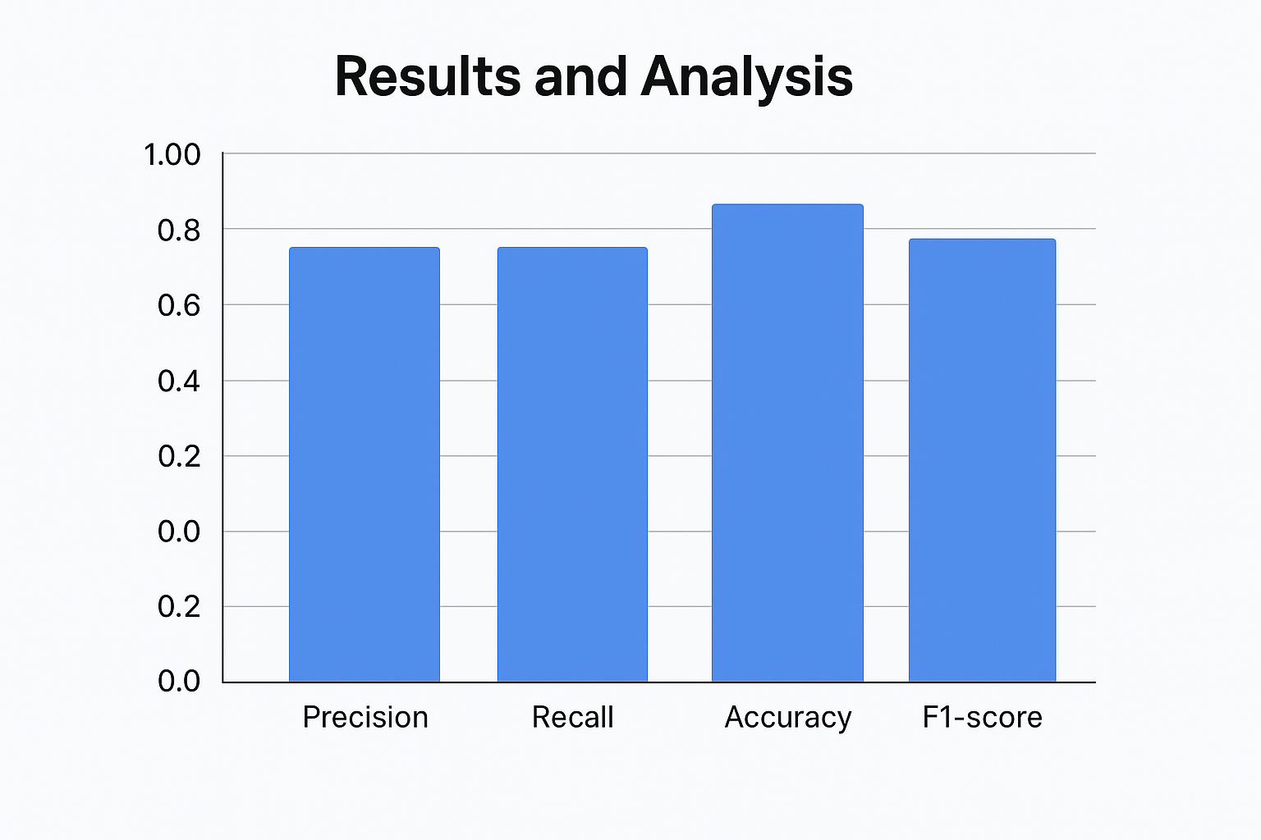

# Conclusion & Future work

The College Inquiry Chatbot Project successfully displays the application of condensed AI in the education sector. It provides timely, relevant and automatic assistance to students and applicants. The use of logistic regression for intention classification proves effective and efficient for the prototype-level system. The chatbot significantly reduces administrative charge, user improves experience, and further acts as a foundation for AI integration in college operations.

**Future work:**

* Voice-based interaction: Integrate speech-to-text and text-to-spicch module.
* Multilingual support: expand chatbot capabilities to support regional and international languages.
* Deep Learning Model: Use models like Burt or LSTM for better understanding of complex questions.
* Chat analytics: Analyze chat logs to identify trends and improve information spread.
* Mobile App Integration: Develop indigenous or hybrid mobile apps with chatbot support.
* Third-party integration: CRM system, email and link with student database.

# References

* Jurffski, D., and Martin, J. H. (2020). Speech and language processing.
* Scikit-LARN Documentation: https://scikit-larn.org/
* Python NLTK Library: https://www.nltk.org/
* Flask Web Framework: https://flask.palletsprojects.com/
* IBM Watson Assistant: <https://www.ibm.com/cloud/watson-sstant>
* Dialogflow by Google: https://cloud.google.com/dialogflow
* Wellianos, G. (2018). "Chatbots in Education: A research synthesis." British Journal of Educational Technology.
* Microsoft Bot Framework: https://dev.botframework.com
* Spacy NLP Library: https://spi.io/
* Burt by Google AI: https://github.com/google-Research/bert